Washburn Student Government Association
Surritt/Henry Administration, 8/29/18
- Call to Order – Jim Henry
- Roll Call – Michael Guerrero
- Review of Minutes
- Executive Staff Reports
  - Community Affairs Director Rodriguez
  - Campus Affairs Director Fox
  - Marketing Director Baker
  - Public Relations Director Tobin
  - Legislative Research / Diversity Director Hodge
  - Administrative Assistant / Technology Director Guerrero
  - Budget Director Walker
  - Chief of Staff Weinbrenner
  - Vice President Henry
  - President Surritt
  - Advisor Barraclough
- Committee Reports
  - Allocations Chairperson
  - Campus Affairs Chairperson
  - Communications Chairperson
  - Student Engagement: Elect New Chair
- New Business I
  - SB 18-19 #006: Christman Appointment
  - SB 18-19 #005: Goodheart Appointment
  - SB 18-19 #007: Stanley Appointment
  - SB 18-19 #008: Holley Appointment
- Public Forum I
  - Swearing in New Senators
- New Business II
  - SB 18-19 #009: Senator for International Students
  - SB 18-19 #010: Annual Budget
  - SB 18-19 #011: Office Policy
- Public Forum II
  - Appoint new Internal Finance member
- Announcements
- Roll Call
- Adjournment

SB 18-19 #005

TITLE: Christman Appointment
ORGINATOR: Nominating Committee
SPONSOR: Surritt Administration
STATUS: Nominating Committee – Favorable

WHEREAS: Qualified Senators are essential to the function of WSGA, and

WHEREAS: Matthew Christman is qualified to serve as a WSGA Senator, and

WHEREAS: Matthew Christman has met all necessary requirements set forth by the Nominating Committee.

THEREFORE BE IT ENACTED:

SECTION ONE: The Washburn Student Government Association Senate hereby approves the appointment of Matthew Christman to serve in the capacity of Senator.

SECTION TWO: This legislation shall become effective upon passage.

Zac Surritt Jim Henry
WSGA President WSGA Vice President

SB 18-19 #006

TITLE: Goodheart Appointment
ORGINATOR: Nominating Committee
SPONSOR: Surritt Administration
STATUS: Nominating Committee – Favorable

WHEREAS: Qualified Senators are essential to the function of WSGA, and

WHEREAS: Kayli Goodheart is qualified to serve as a WSGA Senator, and

WHEREAS: Kayli Goodheart has met all necessary requirements set forth by the Nominating Committee.

THEREFORE BE IT ENACTED:

SECTION ONE: The Washburn Student Government Association Senate hereby approves the appointment of Kayli Goodheart to serve in the capacity of Senator.

SECTION TWO: This legislation shall become effective upon passage.

Zac Surritt Jim Henry
WSGA President WSGA Vice President

SB 18-19 #007

TITLE: Stanley Appointment
ORGINATOR: Nominating Committee
SPONSOR: Surritt Administration
STATUS: Nominating Committee – Favorable

WHEREAS: Qualified Senators are essential to the function of WSGA, and

WHEREAS: Emily Stanley is qualified to serve as a WSGA Senator, and

WHEREAS: Emily Stanley has met all necessary requirements set forth by the Nominating Committee.

THEREFORE BE IT ENACTED:

SECTION ONE: The Washburn Student Government Association Senate hereby approves the appointment of Emily Stanley to serve in the capacity of Senator.

SECTION TWO: This legislation shall become effective upon passage.

Zac Surritt Jim Henry
WSGA President WSGA Vice President

SB 18-19 #008

TITLE: Holley Appointment
ORGINATOR: Nominating Committee
SPONSOR: Surritt Administration
STATUS: Nominating Committee – Favorable

WHEREAS: Qualified Senators are essential to the function of WSGA, and

WHEREAS: Joseph Holley is qualified to serve as a WSGA Senator, and

WHEREAS: Joseph Holley has met all necessary requirements set forth by the Nominating Committee.

THEREFORE BE IT ENACTED:

SECTION ONE: The Washburn Student Government Association Senate hereby approves the appointment of Joseph Holley to serve in the capacity of Senator.

SECTION TWO: This legislation shall become effective upon passage.

Zac Surritt Jim Henry
WSGA President WSGA Vice President

SB 18-19 #009

TITLE: Senator for International Students
Originator(s): Senator Paul Mismaque
SPONSOR: Senator Paul Mismaque, Senator Trae McPherson
STATUS: Committee of the Whole – PENDING

WHEREAS: The Washburn Campus has more than 350 International Students.

WHEREAS: The Washburn Student Government Association’s purpose is serving students of Washburn University.

WHEREAS: Washburn Student Government Association is responsible for establishing a true representation of the Student Body.

THEREFORE, BE IT ENACTED BY THE SENATE:

SECTION ONE: Article II, Section 2, of the WSGA Constitution shall be amended to read as the following with insertions using parentheses and deletions using strikeout:
SECTION 2. The WSGA Senate shall be comprised of thirty-four (34) total senators ((Twenty-six (26) Senators shall be elected each year by the WSGA at-large in accordance with the WSGA By-laws. Two (2) seats shall be filled in the fall by transfer students through an open-seat process. ((One (1) seat shall be filled by an International Student appointed by the President.)) The remaining five (5) seats shall be filled by university-classified freshmen elected by the freshman class during freshman elections.

SECTION TWO: Chapter 3, Section 3, of the By-Laws relating to the Chief of Staff shall be amended to read as the following with insertions using parentheses and deletions using strikeout:
By inserting a new point 12, and renumbering thereafter:
12. ((To coordinate with the International House to find an eligible student to serve as a Senator for International Students, and recommend qualified students for appointment to the President.))

SECTION THREE: Chapter 5, Section 1, of the By-Laws relating to the Qualifications for Office for Senators shall be amended to read as the following, with insertions using parentheses and deletions using strikeout:
By inserting a new point B, and re-lettering thereafter.
B. ((The Senator for International Students must fulfill the qualifications of any other Senator, adding that the Senator for International Students must be able to communicate in english, and must demonstrate understanding of their role as a representative of student interests and welfare at Washburn.))

SECTION FOUR: This bill will be amending the Constitution of the Washburn Student Government Association, and it will be amending Chapter 5 the Election By-Laws. For this bill to come into effect lawfully, it must pass with a 2/3rds majority roll call vote of the total membership of the Senate, and must be heard twice before being voted for passage.

SECTION FIVE: After passage, the final form of this bill shall be distributed to the International House, the Office for Diversity and Inclusion, and to Washburn President Dr. Farley.

SECTION SIX: After passage, The Public Relations Director is directed to release a press statement to the Washburn Review, about the addition of a Senator for International Students.

SECTION SEVEN: This bill shall come into effect after passage provided that there are currently empty at-large Senate seats. Should the Senate have all at-large seats filled, this bill will come into effect April 2019 for the next election of the Senate.

SB 18-19 #010

TITLE: 2018-2019 Budget

ORIGINATOR: Surritt/ Henry Administration
SPONSOR: Allocations Committee
STATUS: Allocations Committee – PENDING

WHEREAS: The student activity fee of $55 a semester is used to fund the actions of this Senate, and

WHEREAS: The purpose of the activity fee is for WSGA to do the greatest amount of good of the student body.

THEREFORE BE IT ENACTED:

SECTION ONE: The Washburn Student Government Association shall pass the proposed budget for the fall semester of 2018 and the spring semester of 2019.

SECTION TWO: Upon following all rules stated in the constitution, WSGA shall not discriminate up race, sex, religion, creed, age, national origin, sexual orientation, academic major, or level of undergraduate study.

SECTION THREE: This bill shall be effective upon passage.

_____________________ _______________________
Zac Surritt Jim Henry
WSGA President WSGA Vice President

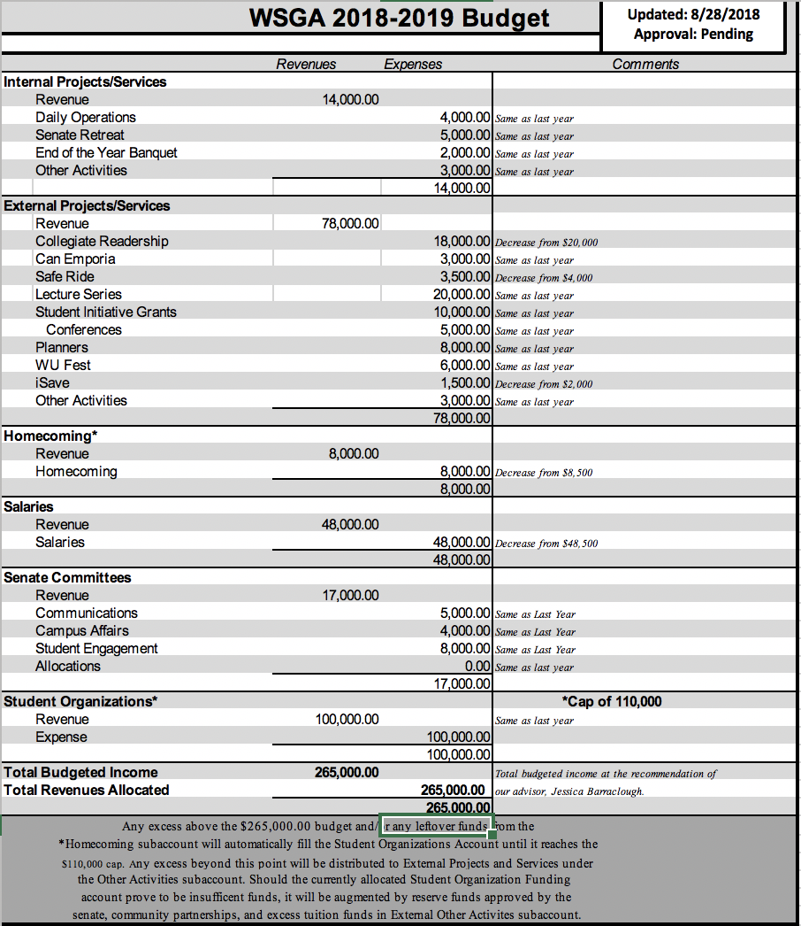

SB 18-19 #011

TITLE: Office Policy
ORIGINATOR: Surritt/Henry Administration
SPONSOR: Surritt/Henry Administration
STATUS: Internal Affairs - PENDING

WHEREAS: The Chief of Staff is entrusted to make and keep an office policy, and

WHEREAS: Such a policy must be approved by the WSGA senate, and

WHEREAS: The following office hour policy is presented to the WSGA senate for their approval.

THEREFOR BE IT ENACTED:

SECTION ONE: The WSGA senate hereby approves the Chief of Staff’s Office Policy.

SECTION TWO: This legislation shall become effective upon passage.

Zac Surritt Jim Henry
WSGA President WSGA Vice President

Washburn Student Government Association
Office Policies and Procedures

Purpose:
The purpose of the WSGA office policy is to provide general operating procedures for the WSGA Executive Staff and Senate. The purpose is not to impose undue restrictions on anyone, rather to provide a uniform set of guidelines so that each person knows what is to be expected. Please act in a professional manner to improve the image of WSGA.

Personal Appearance:
- Senators:
  - Unless otherwise stated or on special occasions, Senate and Committee meetings are business casual attire; this means a button-up shirt, WSGA polo, slacks, khakis, or a skirt or dress. During your office hours, while there is no set wardrobe requirements, we do encourage all senators to look presentable while working in the office. Do not wear any clothes that may be offensive to students or faculty. You’re free to wear jeans, shorts, polos, etc. Absolutely do not wear apparel from other schools while in the office or at Senate meetings: should you do so, your office hour, Senate or committee meeting will be marked absent for that week.
- Executive Staff:
  - The Executive Staff has a required dress code during office hours and Senate meetings. During your office hours and Senate meetings, Executive Staff Members are required to wear, at minimum, business casual. Jeans may be worn as long as they are professional in appearance and do not have rips in them.
- Violations of Dress Code:
  - Violations of the dress code will be addressed by the following:
    - First offense is a warning from the Chief of Staff
    - Second offense will result in half an absence
    - Third Offense will result in another half absence in addition to being sent to the Internal Affairs committee where further reprimands will be decided
Office Hours:
- Senators:
  - All senators are required to conduct a minimum of 1 office hour per week. During office hours, senators should be working on WSGA related material. This can include tabling, personal assignments from chairs, favors for Executive Staff, and anything else that needs to be worked on for WSGA. There will be a binder in the office where senators will sign their name when they have completed their office hour. Senators shall also indicate the date and time of which they completed their office hour. If a Senator has not completed their required office hour by each Friday at 5pm, then they will receive half an absence. Office hours must be done while an Executive Staff member is present in the office or if given special permission to conduct the office hour without a Staff member present.

Office Appearance:
- In order to maintain a professional appearance, please maintain a neat and orderly office. Before you leave the office, please throw away your trash and don’t leave things scattered throughout the office.

Telephones:
- The phone should always be answered promptly. Only WSGA Executive Staff and senators should answer the phones.
- When answering the phones be professional and helpful. Answer saying, “Washburn Student Government Association, this is ______.”
- Always place a call on hold, don’t yell across the office.
- If the caller is asking for information and you cannot answer the question yourself, refer the call to someone who should know. If that person is not in the office please take a message and put it in their workstation.
- When taking a message, make sure to include the name of the caller, caller’s telephone number, subject, your name, time of call, and date of call.
- If any Executive Staff member’s phone rings, please do not answer it. Allow it to go to voicemail unless it is the Administrative Assistant’s phone. Since it is the general WSGA number, it needs to be picked up at all times. It can be answered from any phone in the office by picking up the receiver and pressing the “pickup” button.

Office Rules:
- Senators may not be in the office after 5pm unless they have consent from the President, Vice President, or Chief of Staff, or if they are accompanied by an Executive Staff member.
- In order to maintain a professional appearance, please maintain a neat and orderly office. Before you leave the office, please throw away your trash and don’t leave things scattered throughout the office.
- Please throw away food trash in trash bins outside the office. If this becomes a serious problem, food in the office will be restricted.
- When someone comes into the office, greet them promptly and in a friendly professional manner.
- Executive Staff are responsible for greeting each senator as they come in to work their senator hour. Help them determine what needs to be done.
- If the media call/ come to office please forward them to either the Chief of Staff, Public Relations Director, or the Pres./V.P.
- During a WSGA election, the office is and will be a neutral zone. The Executive Staff or Senators should not use any WSGA equipment that would assist a candidate in their campaign.

Computers:
- Please note that the computer is intended only for use by senators and Executive Staff.
- Don’t save any personal files on the computer. Bring a disk or jump drive.
- Don’t view inappropriate material on the internet.
- Computers are to be used only for school and WSGA related work. To make sure all work is finished promptly, please refrain from Netflix or social media sites (Facebook, Twitter, Reddit, etc.) except for school purposes. We must enforce this. Do not waste someone else’s working time.
- You may play music as long as it is at an appropriate level and does not impede on others work
- If a problem occurs with any of the computers, please notify a staff member so they can contact ITS.

Things NOT to do:

- Do not move Executive Staff chairs
- Do not put trash in the recycling bins
- NO THROWING THINGS
- During WSGA event weeks sit up front
- Don't take supplies from exec desks
- DO NOT Steal scissors
- Don't sit at Exec desks unless allowed

**We encourage you to come hang out, eat lunch, or study in the office during breaks from class. Please be courteous of those senators and executive staff working while you are in

